|  |
| --- |
| DICKINSON IRON  COMMUNITY SERVICES AGENCY |

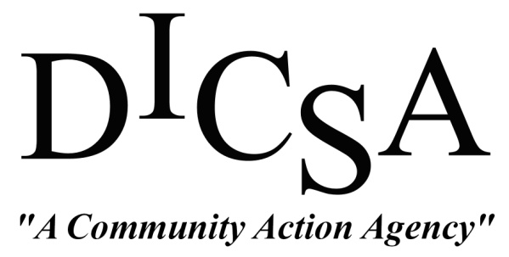

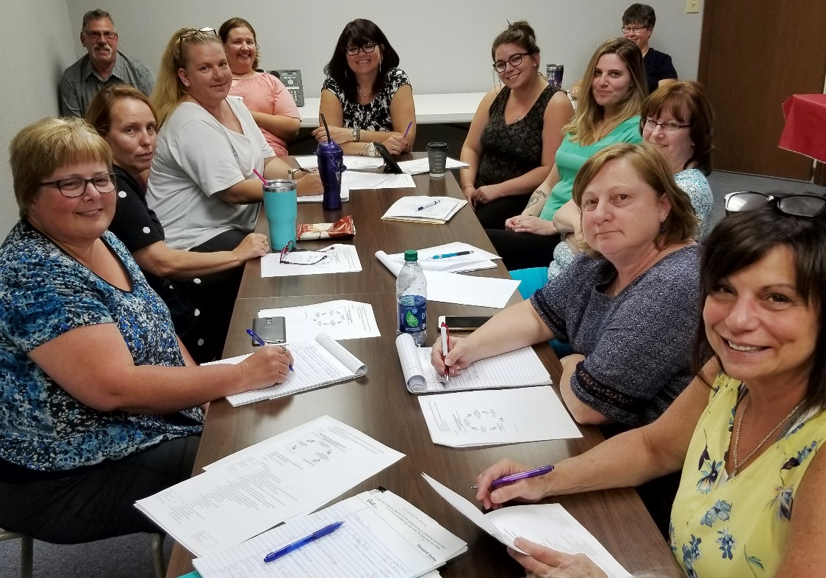

**Community**

**Needs**

**Assessment**

**2019**

About

Since 1989, the Dickinson Iron Community Services Agency has been a leader in providing opportunities to improve the lives of individuals and families throughout our region.

DICSA is a non-profit Community Action Agency serving primarily Dickinson and Iron Counties. Our mission is to focus and coordinate all available resources that empower individuals to obtain the opportunities to become self-sufficient.

We are governed by a 9-12 member tri-partite board made up of representatives from the public (elected officials), private, and low-income sectors of our communities. DICSA is funded by federal, state, and local grants, UPCAP, the United Way of Dickinson County, local senior millage and private foundations.

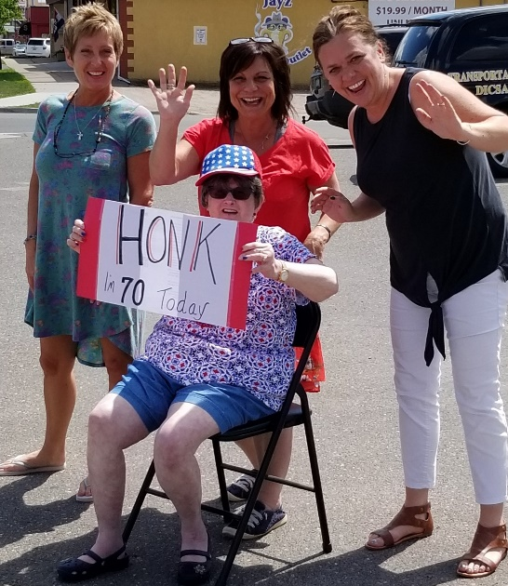

In 2018, DICSA served over 1,800 community members. We operate 14 different programs and employ an average of 73 people, all committed to making a difference.

Introduction

DICSA conducts a formal Community Needs Assessment every 3 years to collect and analyze information regarding the issues impacting our service area. The information generously provided by respondents helps ensure that DICSA’s programs and services continue to be relevant and responsive to expressed needs within these areas as resources permit.

The Community Needs Assessment is used to gain insight into what challenges are faced by members of the community, identify gaps in services and potential unmet needs, and guide programming, collaborations and grant-seeking to meet those needs.

Methodology

DICSA staff held internal meetings and discussions along with following the standards put forth by our state partners to assemble the 2019 survey. A 23-question assessment (both online and hard copy) was distributed in June of 2019 to the community via emails, website links, senior centers, housing complexes, community agencies, and partner organizations. 169 surveys were collected.

Beyond the surveys, local demographic data was gathered using the Cares Engagement Network which accesses over 30 different federal data systems.

This completed report will be distributed electronically to all DICSA contacts, made available on our website, and published/presented in community media and at collaborative gatherings.



2019 Snapshot

Michigan and Local Data

**Population**

* Total Population of State of Michigan: 9,925,568
* Total Population of Dickinson County: 25,694
* Total Population of Iron County: 11,291
* Population Over Age 64 in Dickinson and Iron Counties: 22.35%

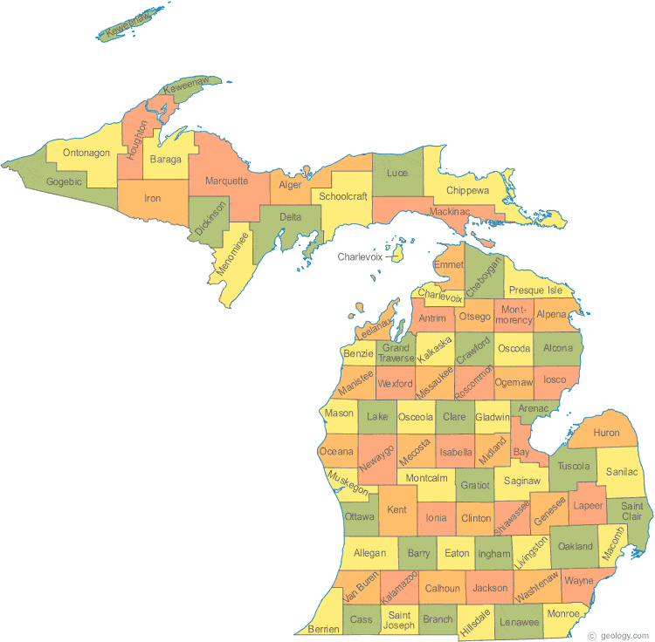**Unemployment**

* Michigan Unemployment Rate: 4.4%
* Dickinson County Unemployment Rate: 4.4%
* Iron County Unemployment Rate: 6.8%

**Income and Poverty**

* Michigan Poverty Rate: 15.58%
* Dickinson County Poverty Rate: 15.24%
* Iron County Poverty Rate: 14.2%
* Michigan Seniors in Poverty Rate: 8.2%
* Dickinson County Seniors in Poverty Rate: 9.7%
* Iron County Seniors in Poverty Rate: 8.0%
* Michigan Median Household Income: $54,840
* Dickinson County Median Household Income: $48,291
* Iron County Median Household Income: $42,082
* US Median Household Income: $60,336

Data Sources: American Community Survey 2017; US Census Bureau Report; US Bureau of Labor Statistics

Respondent Profile

**Gender:** Females (70.41%) responded to the community needs assessment in greater numbers than males (29.59%). DICSA’s actual client base is much more evenly distributed with approximately 51% female and 49% male.

**Age:** The distribution for the age of respondents indicates 66% at age 60 or older, which similarly reflects the majority of DICSA’s client base.

Under 20 0 50-59 26

20-29 7 60-69 54

30-39 11 70-79 35

40-49 13 80+ 23

*Total 169*

**Race/Ethnicity:** The race/ethnicity of respondents is representative of Dickinson and Iron Counties. Over 97% responding are white/Caucasian with .59% American Indian or Alaskan Native and 1.78% reporting as Another Race.

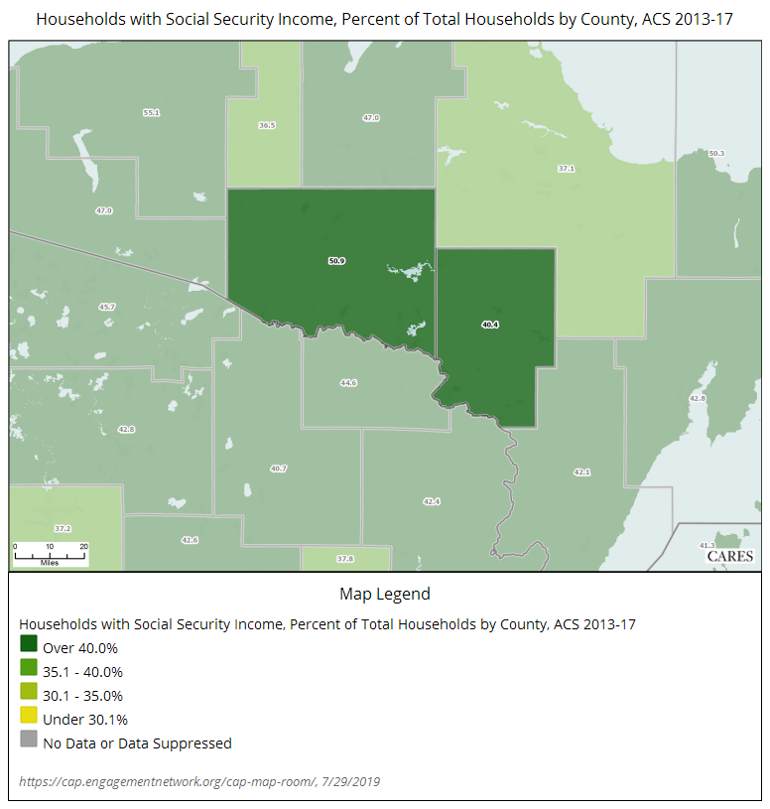

**Living Situation:** 56% of respondents own their home, 40% rent and 3.5% live with someone else. Less than 1% responding are homeless. The percentage of homeowners completing the survey is on track with statistics for the Dickinson and Iron County area, which reports 56.35% owner occupied homes.

**Income:** The household income reported by the respondents trended lower than the median income for the reporting area. 56% of those responding have an annual household income of $29,000 or less. The median income for Dickinson County is $48,291, while Iron County reports $42,082. Since 66% of respondents are 60 years or older, it is fitting that the income trends low, assuming most in that age group are on a fixed social security income (see chart noting that over 40% of total households in the subject area have social security).

**Residency:** 41% of the respondents reside in Dickinson County and 53% in Iron County. The remaining 6% live in neighboring Wisconsin communities. While DICSA’s client base is largely restricted to Dickinson and Iron County residents, some programs are able to serve non-residents. DICSA averages about 60% Dickinson and 40% Iron County residents served in most programs, due mainly to the greater population count in Dickinson County.

**Veteran Status:** 87 % responding are not veterans, while 13% are veterans. This number is reflective of DICSA’s client base, which reports that 12% of the adult population in Dickinson and Iron Counties are veterans.

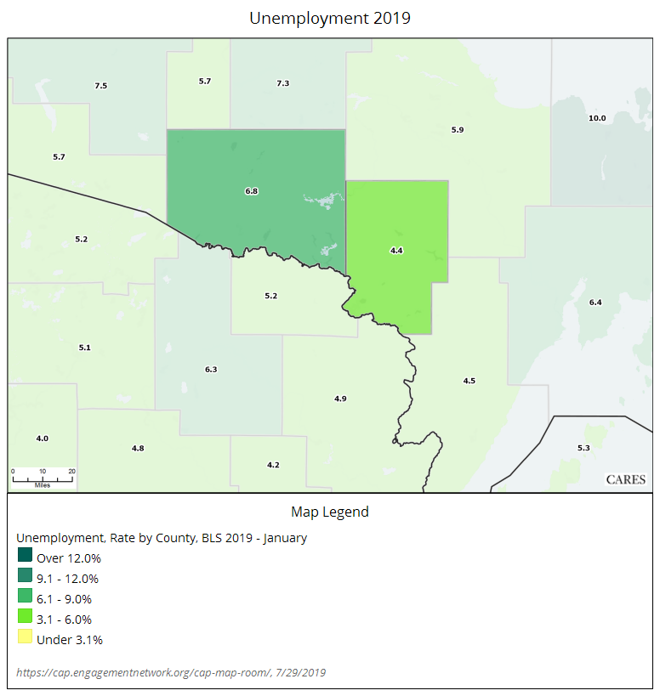

**Employment Status:** Of those responding to the survey, 18% reported being employed full-time; 9% part-time; 56% retired; and 15% unemployed. The unemployment rate of respondents is not reflective of DICSA’s coverage area, which is 4.4% in Dickinson County and 6.8% in Iron County.

Key Findings

The 2019 Community Needs Assessment gathered both qualitative and quantitative data. In addition to the quantitative demographic data listed in the Respondent Profile section, we also gathered information on household size, number of children under age 12 living in the household, and whether or not respondents were covered by health insurance.

Overall, the quantitative data such as unemployment rates and median income levels point to the conditions of poverty in our area. Qualitative data collected such as a prevalence of substance abuse, a lack of public transportation, and a lack of access to mental health care all point to the causes of poverty.

A summary of qualitative data collected follows.

**Safety:** When asked if they feel safe in their community, 92% of respondents cited that they feel safe most or all of the time.

**Quality of Life:** Participants were asked to rate 20 statements related to quality of life by choosing the answer that best represents how satisfied they are with the services, programs or access to care in their community.

70% of respondents said they were very satisfied or satisfied with the programs that support seniors; 67% said they were very satisfied or satisfied with the programs that assist with food distribution and nutrition needs.

The statements with the highest percentages of respondents stating they are ‘satisfied’ included:

* Access to quality health care
* Opportunities to participate in community activities
* Access to programs that support senior citizens

The statements with the highest percentages of respondents stating they are ‘not satisfied’ included:

* Access to needed transportation
* Access to quality mental health services
* Opportunities for employment

**Community Concerns:** Respondents were asked to choose their most important community concerns and cited the following top four out of list of 12 options:

* Senior services
* Transportation
* Affordable housing
* Quality employment opportunities

**Critical Issues:** Respondents were asked to choose which they felt were the three most critical issues facing our community out of 21 choices:

* Substance abuse
* Mental health services
* Employment

**Most Needed Services:** When asked to choose from 19 listed community programs/services, respondents noted that the services they’d most like to see continue included:

* Home delivered meals
* Congregate meals
* Transportation – Buzzin’ Around Town bus/van
* Mental health
* Housing assistance

When asked to choose only one service to receive from those DICSA provides, respondents ranked the below as their top three:

* Home delivered meals
* Transportation
* In-home services

**Unmet Needs:** The survey asked about needs or concerns that the community does not meet. Respondents’ top three included:

* Public transportation
* Dental care
* Mental health services

Nearly 31% of the people, equal to the percentage who chose public transportation, answered that there were no needs their community does not meet.

Analysis & Next Steps

The 2019 Community Needs Assessment offers a glimpse into the challenges people face in their everyday lives in our local communities. The overall demographics of those who completed the survey indicate that the majority of respondents are similar to the individuals and families we typically work with on a day to day basis. Responses provide a general reference point when looking at programmatic planning for DICSA.

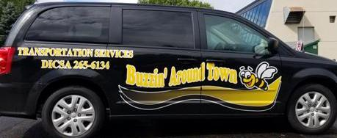The 2013 and 2016 surveys listed public transportation as one of its top three community needs. In 2019 it is still a community concern. DICSA provides limited public transportation with our Buzzin’ Around Town vans. We’ve recently worked very hard to restructure and improve our transportation program and continue to seek feasible ways to enhance our capacity. Partnerships will likely be the means to remove public transportation from the top of the list of community needs. An increase in the per mile subsidy received via grant funding would be significant in growing our program and serving the greater need.

Four of DICSA’s programs ranked among the top five most needed services in the community. We will work to ensure that those programs are effectively marketed, managed and delivered. Our area has a large population of older adults and the survey indicates that senior services are a key concern. Therefore, DICSA must continue to focus resources on the programs that provide senior assistance. Seeking private donors and generating income outside of grant funds will be necessary for sustainability as grant funding stagnates across all programs.

For the areas of community concern that DICSA does not directly address through programming (e.g. substance abuse, mental health, dental care, etc.), our staff is committed to making solid referrals and collaborating with our community partners to ensure accurate knowledge of resources available.

As our mission states, DICSA strives to empower individuals to obtain the opportunities to become self-sufficient. Our staff and board will continually evaluate the needs of our community in order to build up all who call this area home. *#DICSASTRONG*