RSVP
A program of the
Dickinson Iron Community Services Agency
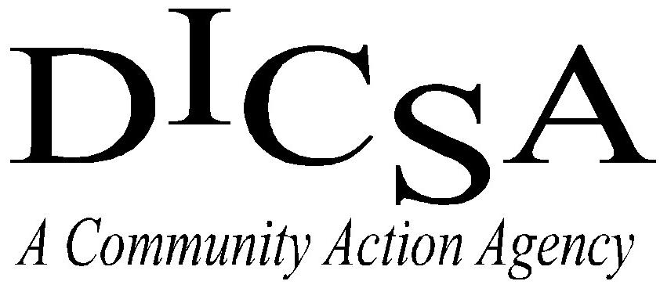

Volunteer Handbook
Retired and Senior Volunteer Program
of Dickinson & Iron Counties
800 Crystal Lake Blvd., Suite 104
Iron Mountain, MI 49801
906-774-2256
www.dicsami.org

Welcome to RSVP
The Retired and Senior Volunteer Program (RSVP) of Dickinson and Iron Counties welcomes the vast talents of those 55 years and older willing to share their experiences, abilities and skills to meet a wide variety of community needs. It is the intent of RSVP to provide opportunities for purposeful activities, which benefit both the community and the volunteer.

You are joining an organization that has a long tradition of helping others and building strong and healthy communities. Not only are you a member of a local program, you are part of a movement that started in 1971 and has continued to gain momentum throughout its years of success.

RSVP volunteers bring skills, talents, and years of experience to the communities in which they serve. RSVP volunteers make a difference. And, YOU will make a difference through the skills, talents, and experience that you bring to the Dickinson Iron Community Services Agency’s Retired and Senior Volunteer Program.

Funding
The main source of funding for the Dickinson Iron RSVP project is the Michigan Office of Services to the Aging. Additional support for the program is received from the Corporation for National and Community Service and the local community.

History
The Retired and Senior Volunteer Program began in 1971. It was authorized as a Federal program under Title II, Part A, of the Domestic Volunteer Service Act of 1973, which paved the way for the growth and success of this national volunteer program. Since 1993, the Corporation for National and Community Service has administered RSVP. The purpose of the program is to provide a variety of opportunities for retired persons, aged 55 or older, to participate more fully in the life of their community through significant volunteer service.

The Dickinson Iron RSVP began in October of 2001. As of 2012, there were 676 RSVP projects active throughout the United States. Twenty-three of those projects are in the State of Michigan. Each year, more than 320,000 individuals over the age of 55 serve as RSVP volunteers, through more than 63,000 public and non-profit community organizations, contributing more than 47 million hours of service throughout the country.

Who can become an RSVP volunteer?
RSVP Volunteers are men and women over the age of 55 who are interested in sharing their skills and talents with the communities in which they live. There are no membership fees or income restrictions to join RSVP.

What can RSVP volunteers do?
RSVP volunteers assume many roles throughout the communities in which they work and live. Below are a few of the many ways that RSVP volunteers make a difference.
- Tutor students
- Build homes
- Feed and clothe families in need
- Visit and do activities with nursing home residents
- Help at hospitals
- Clean up the environment
- Serve or prep meals
- Care for animals

What if I am already volunteering in the community?
People who are already volunteering in the community are welcome to join RSVP. There are numerous benefits to joining your local RSVP program, including:
- Group activities and opportunities to meet new people
- Accident and liability, and excess auto insurance while ‘on the job’
- Recognition activities
- Opportunity for mileage reimbursement
- Monthly newsletter
- Belonging to a nationwide group of over 320,000 RSVP Volunteers

Enrollment
Anyone interested in learning about RSVP is encouraged to call the office at 906-774-2256.
Enrollment is done through a simple form that must be completed fully and returned to the RSVP office. It is recommended that new RSVP volunteers meet with or call the RSVP director to discuss your interests, experience and learn about possible volunteer opportunities.
Background Checks
The Dickinson Iron RSVP performs background checks on all potential volunteers.

Placement Assistance
The RSVP Director assists volunteers in identifying volunteer opportunities that will be meaningful and satisfying when a volunteer first joins RSVP, and any time thereafter. For placement assistance, call the RSVP office at 906-774-2256.

Volunteer Assignments
Volunteers are matched with volunteer stations according to interests, abilities, preferences, and availability. Volunteer assignments and terms of service, including hours, reflect the individual preferences of RSVP volunteers.

Volunteer Stations
A volunteer station is a public agency, private non-profit organization, or proprietary health-care agency that accepts the responsibility for assignment and supervision of RSVP volunteers. It is the organization where you perform your volunteer service and record on your monthly timesheet.

If you are currently volunteering with an organization that is not an RSVP Volunteer station, encourage them to sign up. The process is simple and there are no financial commitments for stations to join.

Reimbursement
The Retired and Senior Volunteer Program is able to provide limited transportation reimbursement in order to assist in the costs of volunteering. Requesting reimbursement for travel is the choice of the volunteer.

All volunteers requesting mileage reimbursement must have the minimum automobile insurance coverage as required by the State of Michigan.

Mileage is reimbursed to volunteers at a rate of $.40 per mile up to $50 per month. Allowable mileage is travel between the volunteer’s home and the volunteer station. If volunteers ride together (car-pool), only the driver may request reimbursement.

A volunteer must have a supervisor’s signature on the monthly time sheet if mileage reimbursement is requested.

Meal reimbursements are not provided, however if you receive a meal at no cost by your volunteer station, please check it on your monthly timesheet. RSVP can receive in-kind support through meals provided by stations.
Reporting Hours
You play an important role in RSVP’s development. RSVP volunteer hours are essential to funding and maintaining the program. Every hour counts! Accepted methods of reporting volunteer hours include:

- Regular Submission of RSVP Monthly Timesheet
- Timesheets may be mailed, faxed, or delivered in person to the RSVP office. Timesheets should include date of service, station name, activity performed, and total hours served. Volunteers should also sign the timesheet.
- If claiming mileage reimbursement, both the volunteer and the volunteer station supervisor must sign the timesheet. The volunteer must also check the box indicating that you are claiming reimbursement and have the proper license and insurance.

- E-mailing of Volunteer Hours
- Volunteers who are only submitting hours (not requesting mileage reimbursement) may email their hours to the RSVP office. When emailing time, please include date, station name, and hours served.

- Calling the RSVP Office to Report Hours
- Volunteers only submitting hours may also call them into the RSVP office. If leaving a message, please be sure to include your name, station(s) and number of hours.

Please submit timesheets as soon as possible following the end of each month. Mileage reimbursement checks will be mailed to the volunteer’s home address as soon as they are processed by DICSA’s Finance Department.

Record Keeping and How Information is Used
RSVP maintains paper and electronic files on all volunteers. Paper files are kept in a locked office. Electronic files are stored on a secure, web-based reporting system called Volunteer Information System (VIS), created by the Michigan Office of Services to the Aging.

The data entered into VIS is used solely for the purpose of reporting on volunteer demographics and volunteer activity. It is not shared with any other organization or for any other purpose.

Volunteer Appreciation
DICSA’s RSVP hosts at least one special appreciation event each year to thank our RSVP volunteers for their efforts. All volunteers who have contributed hours during the year are invited to attend. Invitations are sent either through the monthly newsletter or individually.

Newsletter
The RSVP Rave is the monthly newsletter sent to all active volunteers and supervisors at volunteer stations. Its purpose is to keep volunteers informed of RSVP activities, volunteer opportunities, pertinent general information and community happenings.

Conduct
When volunteering, an RSVP volunteer must follow the volunteer station’s guidelines for volunteer staff. This includes any requirements for training, attendance, dress code, etc. Any concerns regarding the volunteer station should be taken to the volunteer supervisor at that station.

Weather
RSVP volunteers should follow their station guidelines concerning reporting for volunteer service during bad weather. Your safety is the greatest concern.

Non-Discrimination
No person, on the basis of race or national origin, sex, color, religion or disability shall be excluded from membership or participation in the activities and benefits of RSVP.

Special Limitations for RSVP Volunteers
- Political Activities - No RSVP volunteer may be involved in political activities while serving in the capacity of an RSVP volunteer.
- Religious Activities - RSVP volunteers shall not give religious instruction, conduct worship services, or engage in any form of preaching as a part of their duties.
- Non-Displacement of Employed Workers - An RSVP volunteer may not perform any service or duty, or engage in any activity which would otherwise be performed by an employed worker, or which would supplant the hiring of employed workers.
- Non-Compensation for Services - Under no circumstances shall an RSVP volunteer receive a fee for service from service recipients, their legal guardian, members of their family, or friends. No person, organization, or agency shall request or receive any compensation for services of RSVP volunteers.
- Volunteer Status - RSVP volunteers are not employees of the Dickinson Iron Community Services Agency, the volunteer station, the Corporation for National Service, or the Federal Government.

Volunteer Separation
Volunteers who do not report at least one hour during a 365-day period become inactive as an RSVP volunteer. Inactive volunteers may be re-enrolled in the program upon resumption of active volunteer service.

Volunteers may “retire” from their volunteer assignment at any time by notifying the RSVP director. RSVP staff can also assist the volunteer in locating an alternate volunteer opportunity as needed.

RSVP and its stations may separate an RSVP volunteer for cause, including, but not limited to, extensive or unauthorized absences, misconduct, and inability to perform assignments or accept supervision.

