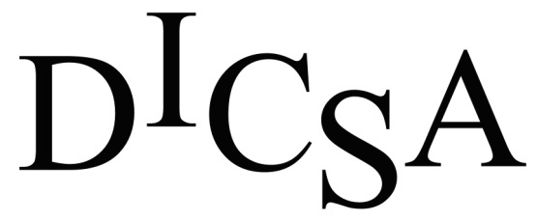

Housing Resource Specialist

The Dickinson Iron Community Services Agency (DICSA) is accepting applications for a full-time Housing Resource Specialist. The Housing Resource Specialist will serve as the first point of contact for individuals experiencing a housing crisis and will assist households with the application/certification process necessary to access various housing programs.

Benefits include health insurance (medical, dental, and vision), life insurance, retirement, holiday pay, and vacation/sick after one year.

A minimum of an Associate’s Degree in Social Work or another Human Services field is required. Must also have at least one year of work experience with at-risk populations.

Please submit a letter of interest and application/resume no later than June 13th to:

Dickinson Iron Community Services Agency
Attention: Human Resources Manager
1238 Carpenter Ave.
Iron Mountain, MI 49801
Fax: 906-774-2257

Applications and a full job description are available at our main office or at www.dicsami.org.

DICSA is an Equal Opportunity Employer.

