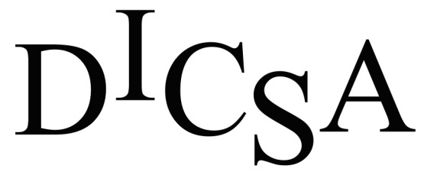

Cook-Sagola

The Dickinson Iron Community Services Agency (DICSA) is accepting applications for a part-time cook to work at the Sagola Senior Center, Sagola, MI. This position is for Tuesday, Wednesday and Thursday, 6-7 hours per day. Interested applicants should have experience with large volume cooking. The position will also be responsible for inventory control, record-keeping, menu planning, and kitchen cleanliness. Applicants should have a strong work ethic, enjoy working with senior citizens, be detail-oriented and a team worker.

Must have a high school diploma or GED. ServSafe Certification is a plus. Must be able to lift 40 pounds and stand for at least two hours at a time.

Enjoy weekends and evenings off, paid holidays, and paid vacation/sick after one year of employment.

Please submit an application to:

Dickinson Iron Community Services Agency
Attention: Human Resources Manager
1238 Carpenter Ave.
Iron Mountain, MI 49801
Fax: 906-774-2257

Applications are available online at www.dicsami.org on the employment tab or call 906-774-2256 for assistance. DICSA is an Equal Opportunity Employer.

