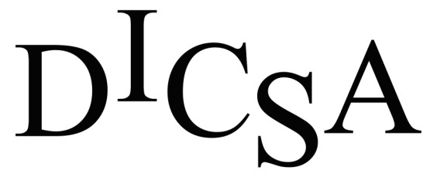

The Dickinson Iron Community Services Agency (DICSA) is accepting applications for a Home Delivered Meal Driver to work in the Iron River area. Job duties include packing and delivery of meals. Applicants must have a clean driving record, a valid license, and current vehicle insurance.

Please submit an application to:

Dickinson Iron Community Services Agency
Attention: Human Resources Manager
1238 Carpenter Ave.
Iron Mountain, MI 49801
Fax: 906-774-2257

Applications are available online at www.dicsami.org on the employment tab or call 906-774-2256 for assistance. DICSA is an Equal Opportunity Employer.

